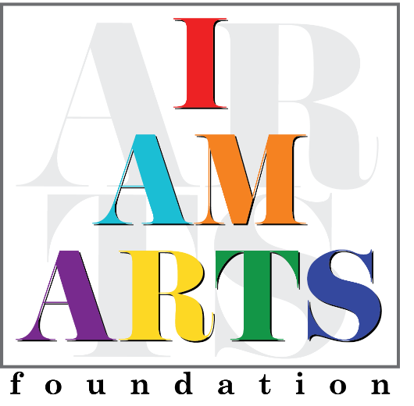

Tara Reddick has a career that spans over 28 years in Real Estate Investments and Property Management. While she has held various positions, she is currently the Accounts Payable/Receivables Manager for HMI Property Solutions, Inc. Tara has had the privilege of serving as a board member for 3 years serving as past Secretary and current Treasurer.
Tara is the mother of two. She has a son, Yeshua, and a daughter, NyAshia. Dr. Mingo entered her life when NyAshia who is now in college was in Prekindergarten. A gifted teacher, Dr Mingo, inspired NyAshia to dance and stirred a passion for the “Arts” in her. NyAshia performed with Dr Mingo and I AM ARTS Dance Company for over fourteen years. During this time, Tara supported the Company by volunteering and helping with fundraisers. She got to witness through NyAshia how important and essential the "Arts" are to child development.
Tara has had an opportunity to watch I AM ARTS grow and establish a strong presence in the community. Cultivating the whole child through music, arts, dance, and community involvement. Tara is an advocate for the arts and has enjoyed supporting I AM ARTS as a patron and volunteer. She continues to support the foundation as well as promote I AM ARTS in her professional circles and community. Tara remains committed to the growth and well-being of I AM ARTS.

