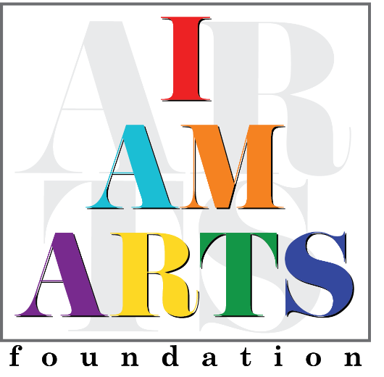

Theresa Mingo, Creative Director, also known as Wise Mecca; is a multifaceted Visual Artist, African Dance & Drummer and Teacher. Wise is a Native of Buffalo, New York and has a Bachelor of Arts degree, as a Cum Laude graduate from Buffalo State College. She was the Artistic Drum Director for the African- American Cultural Center’s Performance Company for nine years. As a teaching Artist she has taught at the Jamestown Arts Gallery, Albright Know Art Gallery, Westminster Schools, Maynard Jackson High School, Burgess Peterson Elementary, Kroc Salvation Army, Buffalo State College, Spellman College, Clark University, Dobbs Elementary, Little Linguists International, the Boys & Girls Club of New York, and The Kindezi School to name a few. Wise is the Creative Arts Director with I AM ARTS Community Partnership; where her artistic prowess has assisted in developing and nurturing well rounded artistic scholars.

Under I AM ARTS umbrella, she mentors and co-directs a performance company that serves young women and men ages 5-18 through the art of dance and cultural enrichment. The performance company has actively made appearances within the Atlanta area including: Relay for Life of South Fulton, Teen Vibez Choreographer’s Showcase, Steve & Marjorie Harvey’s Girls Who Rule the World Foundation & Graduation Ceremony, Performances with Montosho Eshe of Arrested Development, Fundraiser for Tamara Johnson-Shealey Candidate for the Georgia State Senate, District 40, Chocolate Cupcake Lifestyle Brand/Cupcake Run, Judge Penny’s Sister Talk Women’s Empowerment Conference, Zawadi African Dance Performance in New Jersey, Kids Fest &Toy Drive with College Park Councilmen Tracy Wyatt, Juneteenth Atlanta Celebration, Alpha Phi Alpha Black Tie Gala, and a host of churches with the city.

