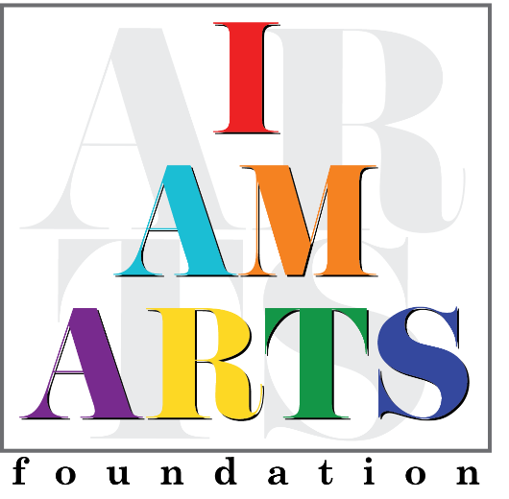

Mashariki Wilson, Service-Learning Coordinator, is originally from Newark, NJ. She is the parent of Mekka Wilson, twenty-year-old alumnae of I Am Arts. Mashariki has been an avid supporter of I Am Arts for over 10 years. For the last 20+years, she has been an educator working with children of all ages. She has been an administrator, teacher and also led the Shining Stars Mentoring program for girls and boys grades 3-8. The love of the arts has also allowed her to follow her passion of learning more about Television and Film production. She has been learning and working on several production projects including the Judge Steve Harvey Show, My Celebrity Dream Wedding, Tyler Perry Studios, and more.

The arts are everywhere and are extremely essential to our community. It is truly important to foster all areas of creativity for all children to help them to become well-rounded individuals. "I Am Arts" is very important in this community and to so many families and children. The love of the all the ARTS that is fostered here by Dr. Tiffany Mingo and Wise-Mecca is why I am a member of this board.

