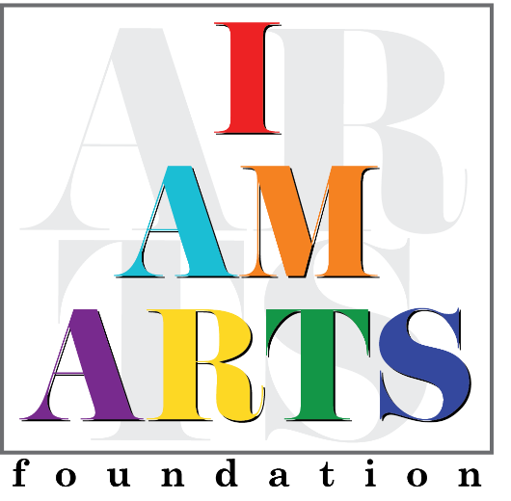

Darnell Jones, Vice Chair, is a globally experienced, value-driven Information Technology professional currently services as a Senior Business Program Manager at Microsoft Corporation. Darnell is a respected industry leader with over 25 years of experience with ranging roles of an IT software analyst, IT developer, IT Consultant, and IT Service Management leader. Her career has included several Fortune 500 companies which includes Equifax, Georgia Pacific, and Cox Enterprises.
Darnell has an innate ability to work with others and motivate teams to excel and exceed organizational objectives. Darnell is a member of the Information Technology Senior Management Forum (ITSMF) and the Women in Technology (WIT), that sponsors high school scholars, and provide college scholarships. Her signature approach which combines a polished, professional image with powerful, personal presence has helped high potential women and girls thrive and advance to their full capability. In addition to her work in the office she volunteers at the Ronald McDonald house servicing their patients, volunteering at the Atlanta Food Bank, Second Helpings Food Rescue and Recovery in Atlanta. City Of Refuges.
Darnell attended Spelman College earning a Bachelor of Arts Degree in Computer Science and later earning a master’s degree in Organizational Leadership Management from Ashford University. Other accomplishments to her credit are ITIL V4 Certification, Business Continuity Plan Certification, and a Holistic Information Security Practitioner Institute Certification. Darnell is a wife and a proud parent to a son and a daughter.

